Collect.Chat – Best AI Chatbot For Our Website

## What is Collect.chat?

[Collect.chat](http://www.soravjain.com/go/collect-chat) which is used on blog or website to connect and collect data from visitors. Its simplicity and amazing features it brings in!

It has helped in building email lists, scheduling appointments, generating leads, collecting feedback, making surveys and much more. A chatbot is the best way to convert your website visitors into customers by engaging them in a conversation rather than asking them to fill forms.  Using a chatbot would mean spending 50% less on sales.

We would no longer have to deal with lines of codes to create a chatbot as collect.chat would do it for us. We can save on a lot of time, as all you have to do is create a chat widget. It supports multiple languages and helps us easily track our chatbot conversations. It also give us insights on the customer responses that we would receive.

## Step-by-step process to set-up your chatbot:

## #Step 1

The first step is to login. In case you don’t have an account, you can create one. It is FREE!

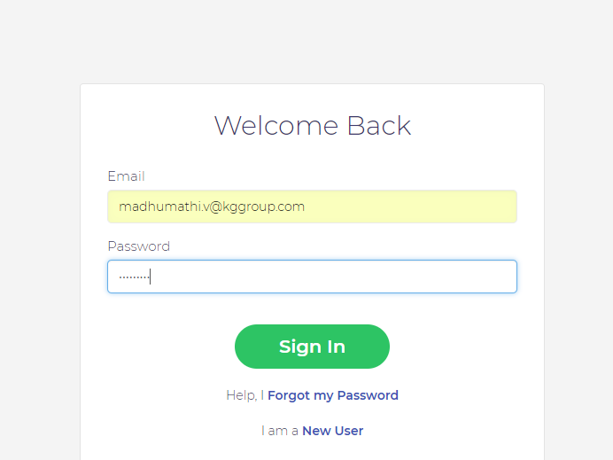

## #Step 2

The next step is to create a New bot. You just have to paste in your website address and you can get started. If you don’t want to do that, you can choose a template and get started.

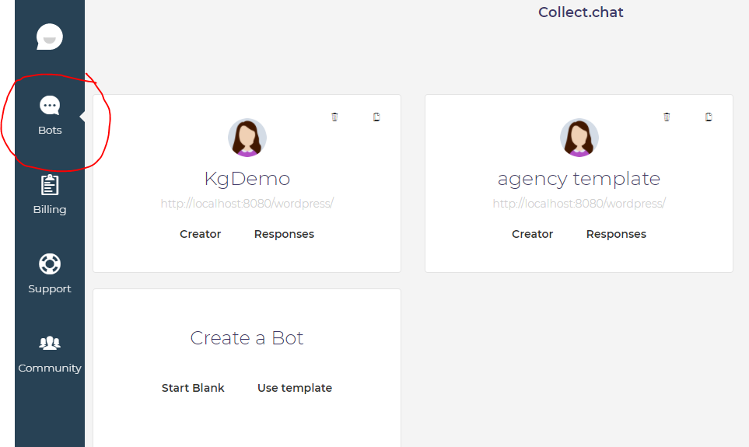

Collect.chat has a lot of templates that you can choose from, having relevant questions that you would want to ask your customers.

## #Step 3

The next thing to do is to get the chatbot ready. Type the text you would want to start the conversation within the Launcher text box. Select the theme colour that you want and the avatar that would suit you. I uploaded my picture in the place of an avatar to add a personal touch.

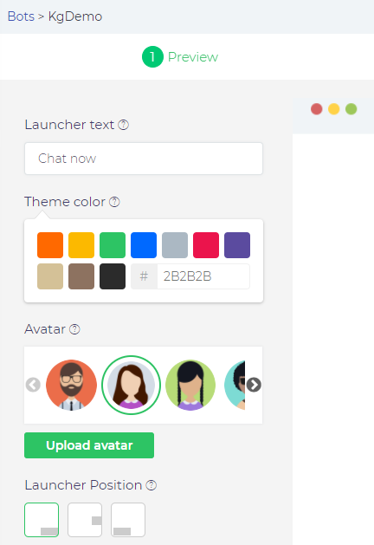

You can also set the position as to where you would want your chatbot to appear.

## #Step 4

Now you have to select the script that you would want to include in your Chabot. It can be a statement or a question. You can also ask for suggestions & feedbacks, your visitor’s email or their contact details. Every answer that you receive would be replied to. For instance, if it is a question which has two options, both the options would have different replies. You can preview how the chat would look like once it is done.

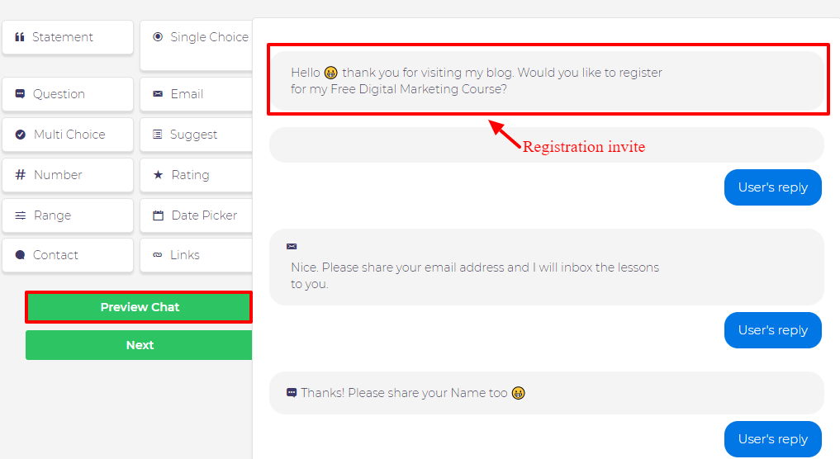

## #Step 5

The next step is to install the code in your website. This can be done in three ways-

* Copy-paste the code snippet
* WordPress plugin
* Mail the developer

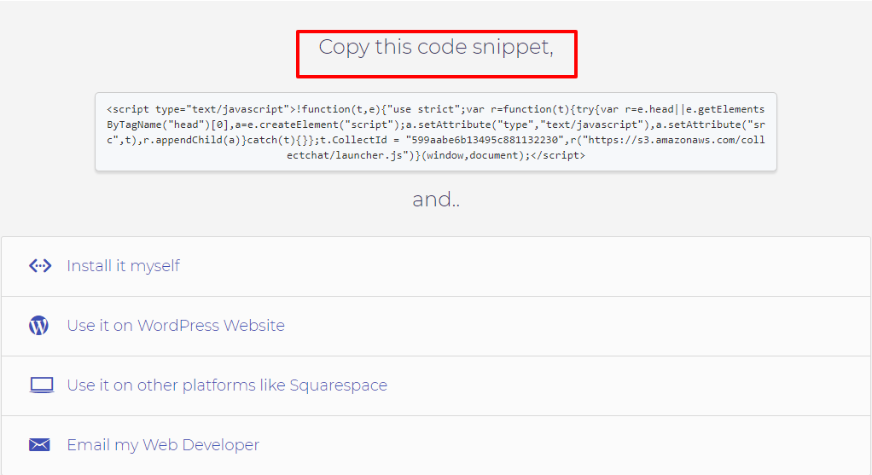

Preview the chatbot once it’s done to see how it would appear. And then your work is done! Now you would get instant notifications in the form of Emails.

## Features

* The best feature of collect.chat is that if you are too busy to build one for your business, it will make one for you. All you have to do is give in your website URL and it will create a template for you.
* Having an active Chabot on your website would increase your conversions as customers are likely to interact 3X more.
* Collect.chat is fully automated, needs no human involvement at all. It doesn’t let your business sleep as it is 24*7 available.
* With the help of Collect.chat you can have engaging conversations with your customers. It is highly interactive as it lets you talk in your customer’s native language, gives them handcrafted questions, GIFs and templates.

# Grow your business with Bots:



### Increase Conversions

Customers are 3X more likely to interact with a website when you reach out with a proactive chat.



### Fully Automated

Collect chat needs 0% human involvement. Let your service agents focus on other important stuff.

Collect.chat is highly interactive to delight your visitors

### Highly Interactive

Delight your customers by talking their native language, using our handcrafted question templates and gifs.



### Be Available 24x7

Collect leads even when all of your sales reps are asleep or on vacation. Don't let your buisiness sleep.

Demo :

1.Chat window integration on website.

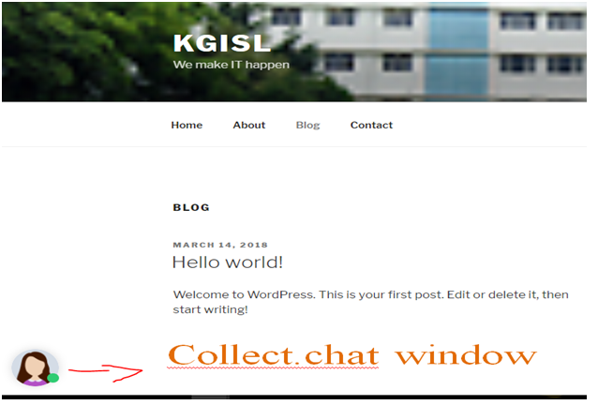

2. Happy chat

